*CST 238: Graphical User Interfaces*

**Puzzle 7 - Memory Management & C++**

**Provided material:**

* Locate and clone the puzzle repository:
  + <https://github.com/StewartTaylor/CST-238/tree/master/Puzzles/Week%207> (Qt/Qml)

After cloned you will have a base project to open and begin working with. You have also been provided images to help build the puzzle described below.

**Puzzle:**

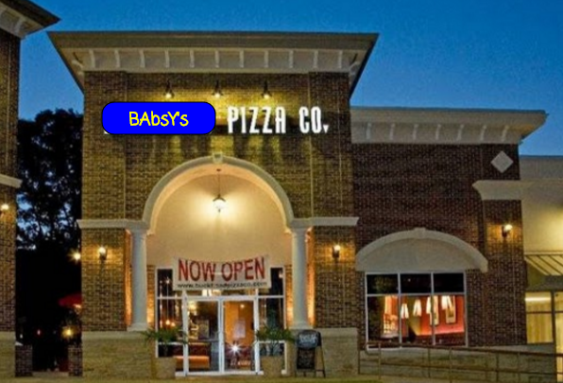

You are a new hire at **Babsy’s Pizza Co**. The restaurant plans to add new “**Digital Order**” tablets for each table. The customer could then punch in their pizza order and press “Confirm Order” to send it off to the kitchen. *Babsy* had previously hired a developer, Gary, to build the application. However, Gary oversold his abilities as a C++ developer and after repeated attempts to fix “visual glitches” Gary was let go.

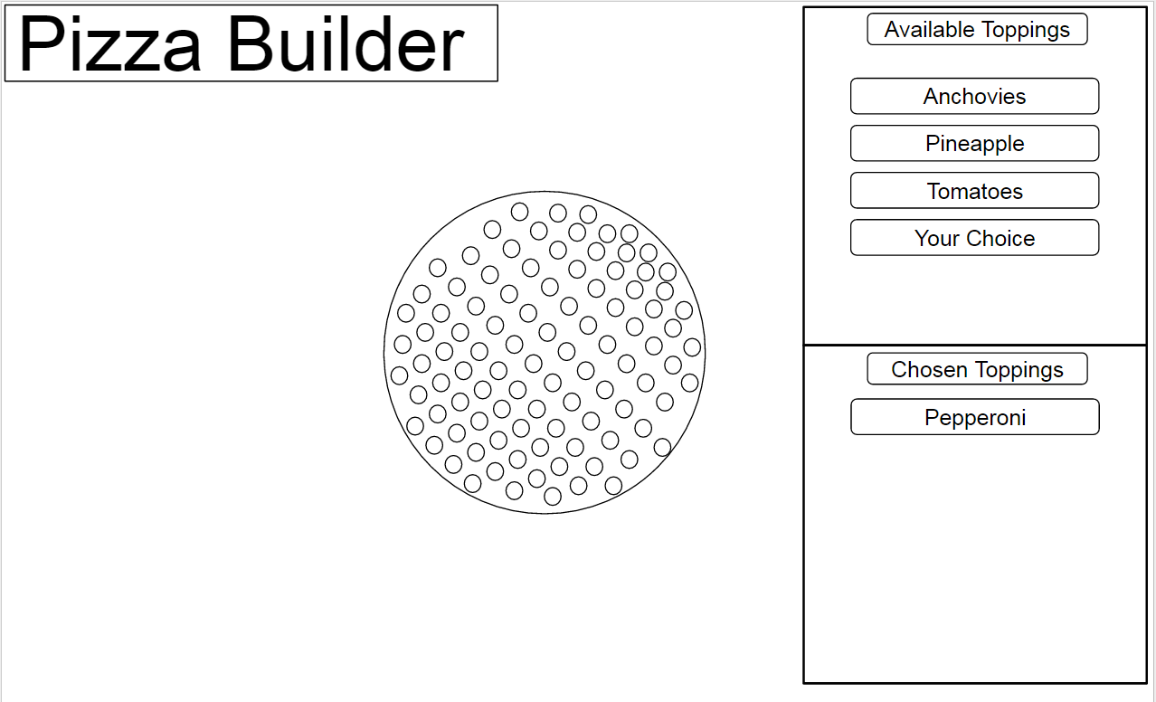

The application was reverted to a state prior to the visual glitches. When reverting the previous developers changes they lost most of the functions of the “Pizza Builder” screen. Gary had written the entire pizza builder system in javascript and QML. While switching toppings the application would temporarily freeze and animations sometimes would behave oddly. *Babsy* asked some of her friends in “I.T.” and they suggested that threading might help. Now *Babsy* has asked you to personally investigate the “threading” and finish the pizza builder screen.

**Objective:**

1. Connect the C++ class “PizzaBuilder” to the Pizza Builder screen in QML.
2. Add the ability to choose toppings (move from available list to chosen list)
   1. C++ data model in Pizza Builder must stay synchronized!
3. ***Finish*** the“PizzaProvider” in C++ to allow drawing chosen toppings as they are added.
   1. Alternatively, you may use Loaders and dynamic QML to draw toppings onto the pizza. BUT YOU MUST STILL SYNCHRONIZE WITH THE C++ DATA MODEL CLASS.
   2. Consider “stacking order of toppings” while drawing them.
4. Add a topping of your choice (Replace the “Your Choice” topping). It should be added to the list as well as have a graphic to draw onto the pizza.
5. (**E.C.**)Add Animations or “fade-in” effects to the Pizza Builder screen.

**Resources:**

Dynamic Object Creation JS

<http://doc.qt.io/qt-5/qtqml-javascript-dynamicobjectcreation.html>

QThreads

<http://doc.qt.io/qt-5/qthread.html>

Qt/Qml Signals

<http://doc.qt.io/qt-5/qtqml-syntax-signals.html>

QRunnable

<http://doc.qt.io/qt-5/qrunnable.html>

**Resources (Code):**

**Week 5 Lecture and source code. (Pixel Buffers)**

[**https://github.com/StewartTaylor/CST-238/tree/master/Lectures/Week%205/Lecture%202**](https://github.com/StewartTaylor/CST-238/tree/master/Lectures/Week%205/Lecture%202)

**Week 6 Lecture and source code. (Dyanmic Objcect Creation)**

[**https://github.com/StewartTaylor/CST-238/tree/master/Lectures/Week%206/lecture%202**](https://github.com/StewartTaylor/CST-238/tree/master/Lectures/Week%206/lecture%202)

**Week 7 Lecture and source code (QThread)**

[**https://github.com/StewartTaylor/CST-238/tree/master/Lectures/Week%207/Lecture%202**](https://github.com/StewartTaylor/CST-238/tree/master/Lectures/Week%207/Lecture%202)